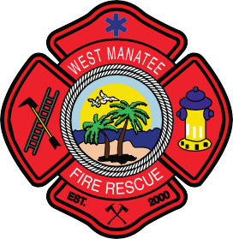
Fire & Life Safety Bureau
“Excellence through Engineering, Education and Enforcement”

How do I know if my portable fire extinguisher has been annually certified?
- Contact a professional: If you are unsure about the status of the certification, it's best to contact a certified fire protection professional or a company that provides fire extinguisher services. They can inspect the extinguisher and provide you with a clear answer about its certification status.
- Check the inspection tag/sticker: Look for a tag/sticker attached to the fire extinguisher. This tag should indicate the last date of inspection or servicing. Every fire extinguisher shall be inspected on a yearly basis.
Regular maintenance and inspection of fire extinguishers are essential for ensuring their effectiveness in case of emergencies.

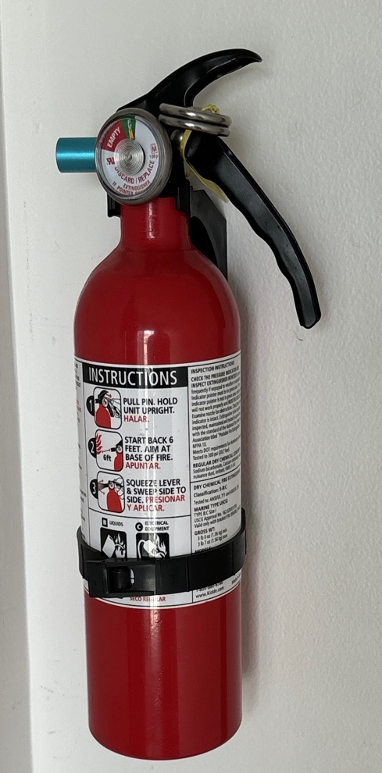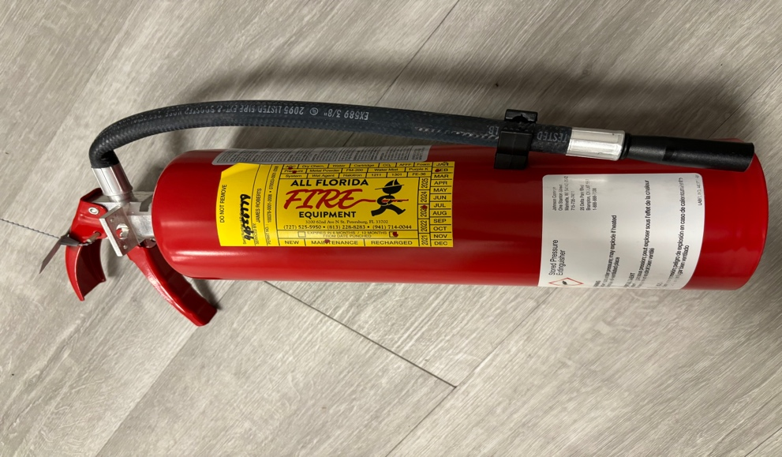
Non-certified Certified
WMFR.org
701 63rd St. W., Bradenton, FL 34209
(941) 761-1555

